A k x k **magic square** is a k x k grid filled with integers such that every row sum, every column sum, and both diagonal sums are **all equal**. The integers in the magic square **do not have to be distinct**. Every 1 x 1 grid is trivially a **magic square**.

Given an m x n integer grid, return *the****size****(i.e., the side length*k*) of the****largest magic square****that can be found within this grid*.

**Example 1:**

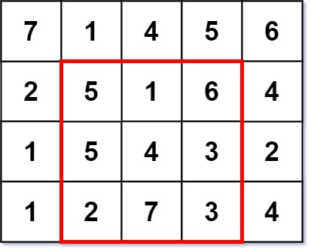

**Input:** grid = [[7,1,4,5,6],[2,5,1,6,4],[1,5,4,3,2],[1,2,7,3,4]]

**Output:** 3

**Explanation:** The largest magic square has a size of 3.

Every row sum, column sum, and diagonal sum of this magic square is equal to 12.

- Row sums: 5+1+6 = 5+4+3 = 2+7+3 = 12

- Column sums: 5+5+2 = 1+4+7 = 6+3+3 = 12

- Diagonal sums: 5+4+3 = 6+4+2 = 12

**Example 2:**

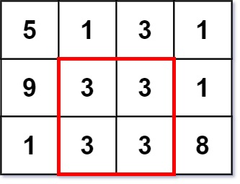

**Input:** grid = [[5,1,3,1],[9,3,3,1],[1,3,3,8]]

**Output:** 2

**Constraints:**

* m == grid.length
* n == grid[i].length
* 1 <= m, n <= 50
* 1 <= grid[i][j] <= 106

s